安装ubuntu
### download ubuntu server, write to udisk, boot from udisk
http://releases.ubuntu.com/14.04/ubuntu-14.04.2-server-i386.iso
写iso到u盘
开机时按F11，用U盘启动，进入安装程序
磁盘分区
24G磁盘分3G，primary , boot flag on, no swap
安装ubuntu server
选中openssh server

Network Manager
root@ihost:~# dmesg | grep nm
[ 4.434775] audit: type=1400 audit(1432558644.543:3): apparmor="STATUS" operation="profile_load" profile="unconfined" name="/usr/lib/Networ
kManager/nm-dhcp-client.action" pid=358 comm="apparmor_parser"

root@ihost:~# ls /etc/resolv.conf -l
lrwxrwxrwx 1 root root 29 May 25 20:47 /etc/resolv.conf -> ../run/resolvconf/resolv.conf
root@ihost:~#

root@ihost:~# ps aux | grep network-manager
root 11405 0.0 0.1 4680 2088 pts/0 S+ 18:12 0:00 grep --color=auto network-manager
root@ihost:~# cat /etc/NetworkManager/NetworkManager.conf | grep dnsmasq
cat: /etc/NetworkManager/NetworkManager.conf: No such file or directory
root@ihost:~#

没有安装network manager

root@ihost:~# cat /etc/resolv.conf
# Dynamic resolv.conf(5) file for glibc resolver(3) generated by resolvconf(8)
# DO NOT EDIT THIS FILE BY HAND -- YOUR CHANGES WILL BE OVERWRITTEN
nameserver 127.0.0.1
root@ihost:~# cat /var/log/syslog | grep dnsmasq
May 25 21:24:45 ihost dnsmasq[3098]: started, version 2.68 cachesize 150
May 25 21:24:45 ihost dnsmasq[3098]: compile time options: IPv6 GNU-getopt DBus i18n IDN DHCP DHCPv6 no-Lua TFTP conntrack ipset auth
May 25 21:24:45 ihost dnsmasq[3098]: failed to access /var/run/dnsmasq/resolv.conf: No such file or directory
May 25 21:24:45 ihost dnsmasq[3098]: read /etc/hosts - 5 addresses
May 25 21:24:59 ihost dnsmasq[3098]: reading /var/run/dnsmasq/resolv.conf
May 25 21:24:59 ihost dnsmasq[3098]: using nameserver 192.168.1.1#53
root@ihost:~#

root@ihost:/etc/network# cat interfaces
# This file describes the network interfaces available on your system
# and how to activate them. For more information, see interfaces(5).

# The loopback network interface
auto lo
iface lo inet loopback

# The primary network interface
auto p4p1
iface p4p1 inet dhcp
root@ihost:/etc/network# cd interfaces.d
root@ihost:/etc/network/interfaces.d# ls -l
total 0
root@ihost:/etc/network/interfaces.d#

root@ihost:~# ifconfig -a
lo Link encap:Local Loopback
inet addr:127.0.0.1 Mask:255.0.0.0
inet6 addr: ::1/128 Scope:Host
UP LOOPBACK RUNNING MTU:65536 Metric:1
RX packets:94 errors:0 dropped:0 overruns:0 frame:0
TX packets:94 errors:0 dropped:0 overruns:0 carrier:0
collisions:0 txqueuelen:0
RX bytes:8093 (8.0 KB) TX bytes:8093 (8.0 KB)

p4p1 Link encap:Ethernet HWaddr 00:e0:4c:68:7a:d7
inet addr:192.168.1.138 Bcast:192.168.1.255 Mask:255.255.255.0
inet6 addr: fe80::2e0:4cff:fe68:7ad7/64 Scope:Link
UP BROADCAST RUNNING MULTICAST MTU:1500 Metric:1
RX packets:146528 errors:0 dropped:0 overruns:0 frame:0
TX packets:59944 errors:0 dropped:0 overruns:0 carrier:0
collisions:0 txqueuelen:1000
RX bytes:141700027 (141.7 MB) TX bytes:4965998 (4.9 MB)

wlan0 Link encap:Ethernet HWaddr 48:d2:24:5f:f4:17
BROADCAST MULTICAST MTU:1500 Metric:1
RX packets:0 errors:0 dropped:0 overruns:0 frame:0
TX packets:0 errors:0 dropped:0 overruns:0 carrier:0
collisions:0 txqueuelen:1000
RX bytes:0 (0.0 B) TX bytes:0 (0.0 B)

root@ihost:~#

scp -P 2708 wlsp@mtxwifi.com:~/pkgsrc/4.1.1-WpcapSrc.zip /usr/src/

root@ihost:/usr/src# apt-get install unzip
root@ihost:/usr/src# unzip -a 4.1.1-WpcapSrc.zip
root@ihost:/usr/src# cd winpcap/wpcap/libpcap
root@ihost:/usr/src/winpcap/wpcap/libpcap# chmod 755 confi*
root@ihost:/usr/src/winpcap/wpcap/libpcap# chmod 755 runlex.sh
root@ihost:/usr/src/winpcap/wpcap/libpcap# ./configure
root@ihost:/usr/src/winpcap/wpcap/libpcap# make shared
root@ihost:/usr/src/winpcap/wpcap/libpcap# make install-shared

root@ihost:/usr/src/winpcap/wpcap/libpcap# ls libpcap* -l
ls: cannot access libpcap*: No such file or directory
root@ihost:/usr/src/winpcap/wpcap/libpcap# ls /usr/local/lib/libpcap* -l
ls: cannot access /usr/local/lib/libpcap*: No such file or directory
root@ihost:/usr/src/winpcap/wpcap/libpcap# ls /usr/lib/i386-linux-gnu/libpcap* -l
-rw-r--r-- 1 root root 315028 Feb 4 2014 /usr/lib/i386-linux-gnu/libpcap.a
lrwxrwxrwx 1 root root 14 Feb 4 2014 /usr/lib/i386-linux-gnu/libpcap.so -> libpcap.so.0.8
lrwxrwxrwx 1 root root 16 Feb 4 2014 /usr/lib/i386-linux-gnu/libpcap.so.0.8 -> libpcap.so.1.5.3
-rw-r--r-- 1 root root 243732 Feb 4 2014 /usr/lib/i386-linux-gnu/libpcap.so.1.5.3
root@ihost:/usr/src/winpcap/wpcap/libpcap#

root@ihost:/usr/src/winpcap/wpcap/libpcap# wlcap -version
tshark: Lua: Error during loading:
[string "/usr/share/wireshark/init.lua"]:46: dofile has been disabled due to running Wireshark as superuser. See http://wiki.wireshark.org/CaptureSetup/CapturePrivileges for help in running Wireshark as an unprivileged user.
TShark 1.10.6 (v1.10.6 from master-1.10)

Copyright 1998-2014 Gerald Combs <gerald@wireshark.org> and contributors.
This is free software; see the source for copying conditions. There is NO
warranty; not even for MERCHANTABILITY or FITNESS FOR A PARTICULAR PURPOSE.

Compiled (32-bit) with GLib 2.39.91, with libpcap, with libz 1.2.8, with POSIX
capabilities (Linux), without libnl, with SMI 0.4.8, with c-ares 1.10.0, with
Lua 5.2, without Python, with GnuTLS 2.12.23, with Gcrypt 1.5.3, with MIT
Kerberos, with GeoIP.

Running on Linux 3.16.0-30-generic, with locale en_HK.UTF-8, with libpcap
version 1.5.3, with libz 1.2.8.

Built using gcc 4.8.2.
root@ihost:/usr/src/winpcap/wpcap/libpcap#

root@ihost:/usr/src/winpcap/wpcap/libpcap# ls libpcap* -l
-rwxr-xr-x 1 root root 275103 May 26 19:11 libpcap.so.1.0.0
root@ihost:/usr/src/winpcap/wpcap/libpcap# ls /usr/local/lib/libpcap* -l
-rwxr-xr-x 1 root root 275103 May 26 19:11 /usr/local/lib/libpcap.so.1.0.0
root@ihost:/usr/src/winpcap/wpcap/libpcap# ls /usr/lib/i386-linux-gnu/libpcap* -l
-rw-r--r-- 1 root root 315028 Feb 4 2014 /usr/lib/i386-linux-gnu/libpcap.a
lrwxrwxrwx 1 root root 14 Feb 4 2014 /usr/lib/i386-linux-gnu/libpcap.so -> libpcap.so.0.8
lrwxrwxrwx 1 root root 16 Feb 4 2014 /usr/lib/i386-linux-gnu/libpcap.so.0.8 -> libpcap.so.1.5.3
-rw-r--r-- 1 root root 243732 Feb 4 2014 /usr/lib/i386-linux-gnu/libpcap.so.1.5.3
root@ihost:/usr/src/winpcap/wpcap/libpcap#

root@ihost:/usr/src# mv /usr/lib/i386-linux-gnu/libpcap.so.0.8 /usr/lib/i386-linux-gnu/libpcap.so.0.8.bak
root@ihost:/usr/src# ln -sf /usr/local/lib/libpcap.so.1.0.0 /usr/lib/i386-linux-gnu/libpcap.so.0.8
root@ihost:/usr/src#
root@ihost:/usr/src# wlcap -version
tshark: Lua: Error during loading:
[string "/usr/share/wireshark/init.lua"]:46: dofile has been disabled due to running Wireshark as superuser. See http://wiki.wireshark.org/CaptureSetup/CapturePrivileges for help in running Wireshark as an unprivileged user.
TShark 1.10.6 (v1.10.6 from master-1.10)

Copyright 1998-2014 Gerald Combs <gerald@wireshark.org> and contributors.
This is free software; see the source for copying conditions. There is NO
warranty; not even for MERCHANTABILITY or FITNESS FOR A PARTICULAR PURPOSE.

Compiled (32-bit) with GLib 2.39.91, with libpcap, with libz 1.2.8, with POSIX
capabilities (Linux), without libnl, with SMI 0.4.8, with c-ares 1.10.0, with
Lua 5.2, without Python, with GnuTLS 2.12.23, with Gcrypt 1.5.3, with MIT
Kerberos, with GeoIP.

Running on Linux 3.16.0-30-generic, with locale en_HK.UTF-8, with libpcap
version 1.0.0, with libz 1.2.8.

Built using gcc 4.8.2.
root@ihost:/usr/src#

root@ihost:/usr/src# java -version
The program 'java' can be found in the following packages:
* default-jre
* gcj-4.8-jre-headless
* openjdk-7-jre-headless
* gcj-4.6-jre-headless
* openjdk-6-jre-headless
Try: apt-get install <selected package>
root@ihost:/usr/src#

设置来电自动启动
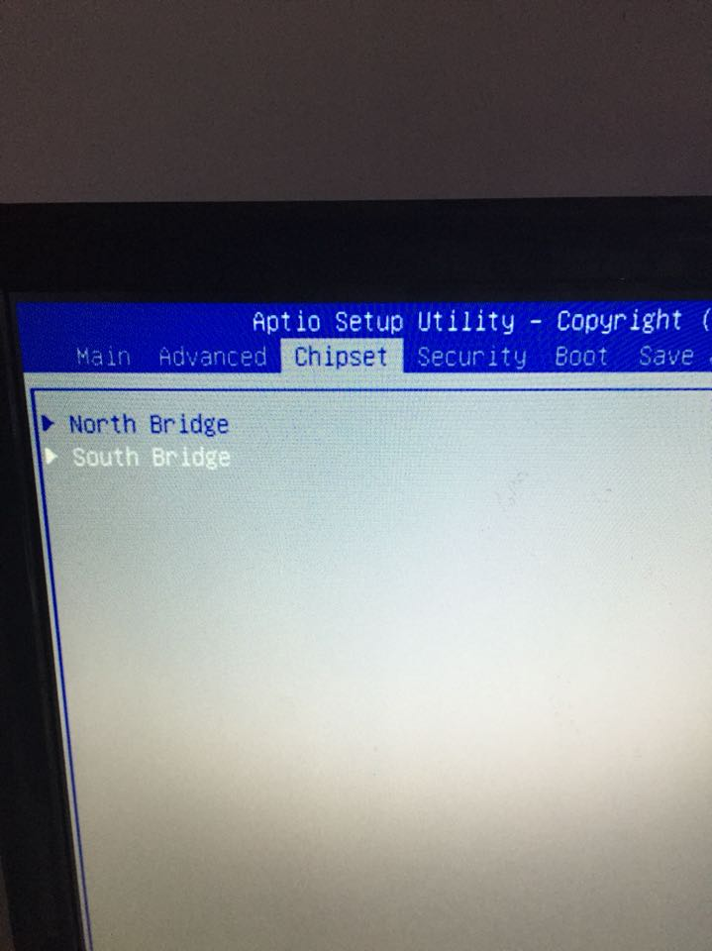
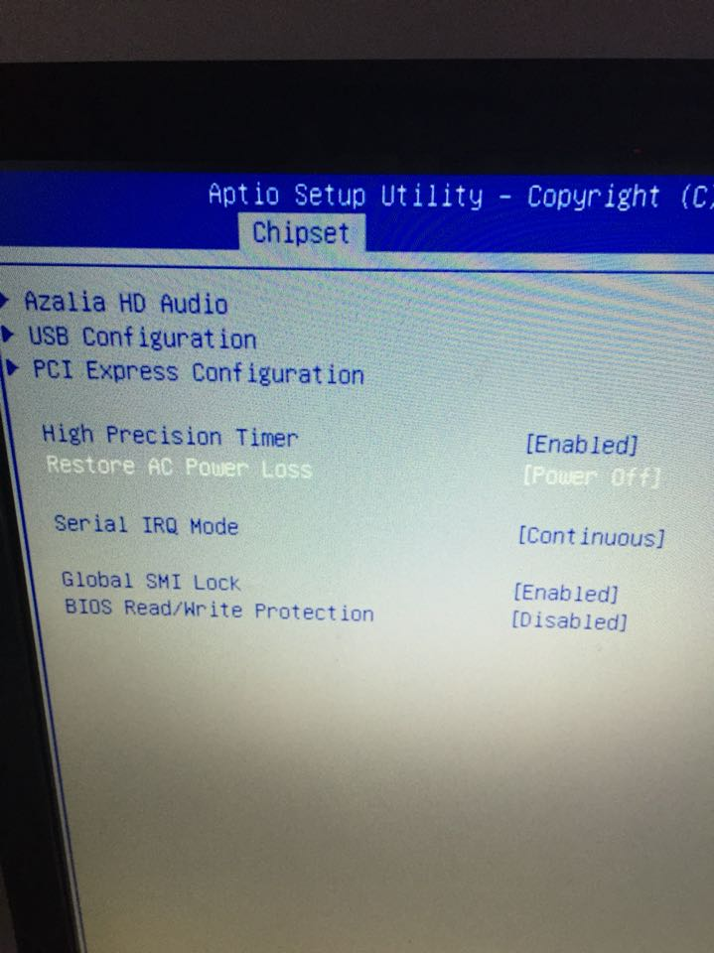

Lan2 p1p1
Lan1 p4p1

